Twitter Towers - README

**Introduction**

Welcome to Twitter Towers, a simple console application that allows users to interact with geometric shapes, specifically rectangles and triangles. Users can select a shape, input its dimensions, and perform various operations such as calculating the perimeter and printing the shape.

Usage

**Getting Started:**

Run the application to get started.

Upon launching, you will see a menu with options to select a rectangle, a triangle, or to exit the program

.

Selecting Shapes:

To select a rectangle, press 1.

To select a triangle, press 2.

To exit the program, press 3.

Inputting Dimensions:

After selecting a shape, you will be prompted to enter the width and height of the shape.

Ensure that the width is greater than or equal to 2, and the height is a positive integer.

Rectangle Operations:

If you choose a rectangle, you will receive information about its area or perimeter, depending on its dimensions.

**Triangle Operations:**

If you choose a triangle, you will have the option to calculate its perimeter or print the shape.

External Dependencies

This project does not have any external dependencies. It is a standalone console application developed in C#.

Assumptions and Simplifications

During the implementation of the project, the following assumptions and simplifications were made:

Input Validation: Basic input validation is implemented to ensure that users enter valid dimensions for the shapes.

Triangle Printing: The printing of triangles is based on certain conditions and may not be accurate for all triangle dimensions.

**Screenshots**

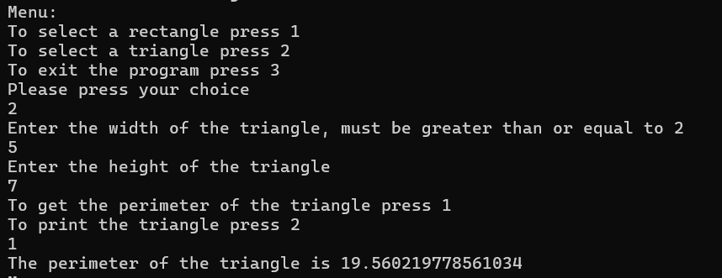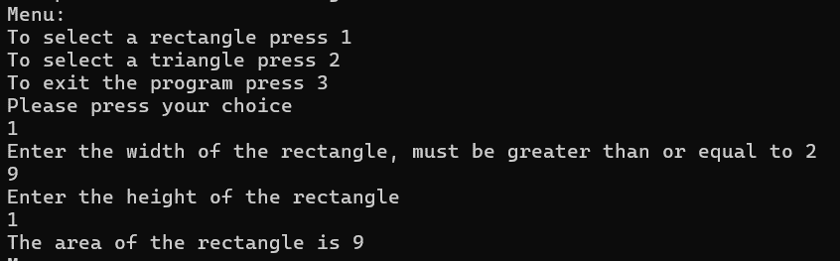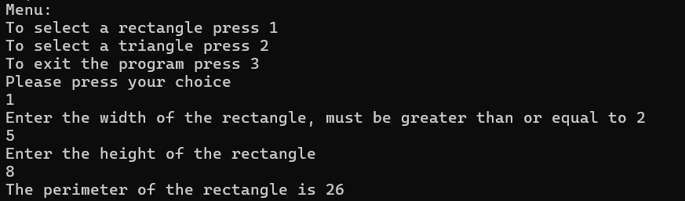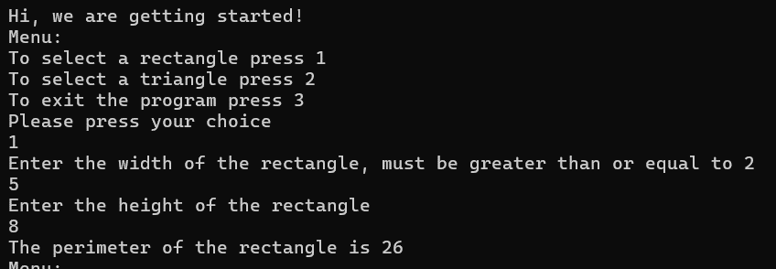

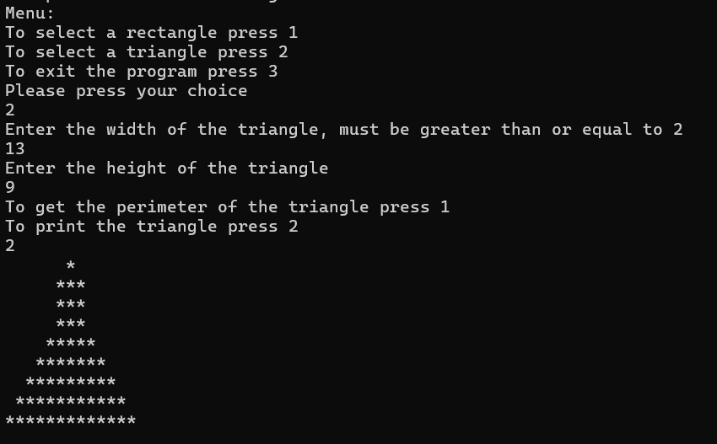

Developed by: Esther Friedman

Contact: estherf5215@gmail.com